C3-S5-PRACTICE

# What you will know?

ORDER BY LIMIT SUM COUNT

**Q1:** Create a database named “doctors_appointment_db”

**Q2:** Import “doctors_appointment_db.sql” into phpymyAdmin

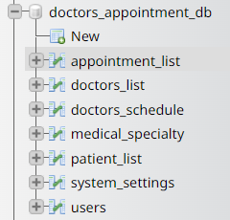

**Q3:** Delete system setting table.



**Q4:** Go to: [mockaroo](https://mockaroo.com/) website

* 1. Create 300 fakes records data for patient list table by having the same patient list in your phpmyAdmin.

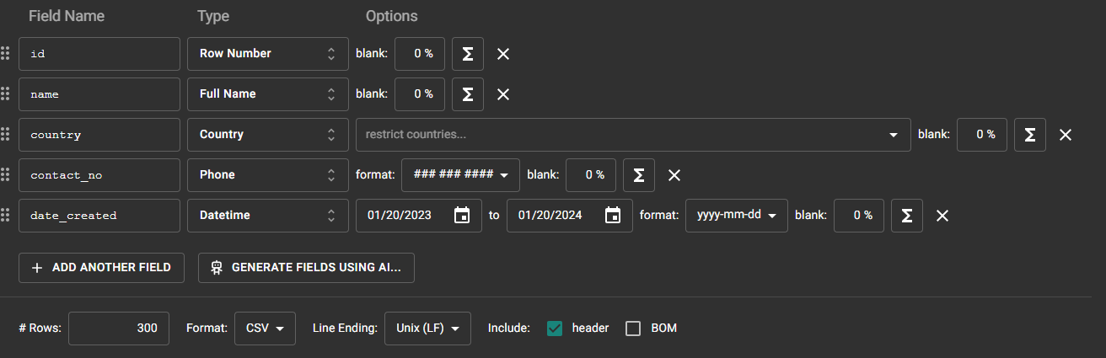

* 1. Import patient_list fake data that you got from mockaroo into doctor_appointment_db into phpMyAdmin

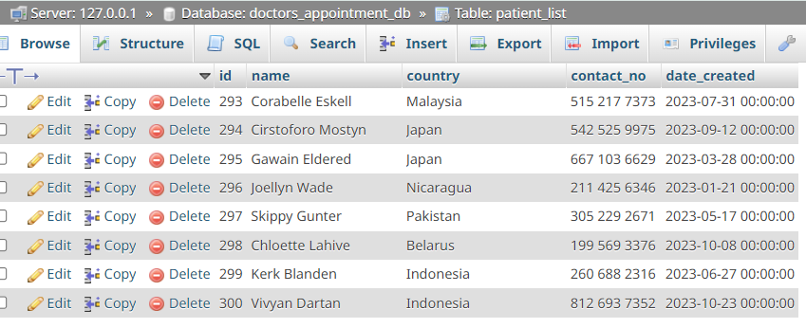

**Q5:** Display the name of the first doctor (alphabetical order) as result below:

Expected result:

Claire Blake

Answer:

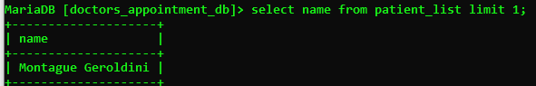

**Q6:** Display the 2 first patients living in France (ordered by their name)

Expected result:

|  |  |
| --- | --- |
| **Name** | **Country** |
| **Charmain Devigne** | **France** |
| **Dredi MacPhaden** | **France** |

Answer:

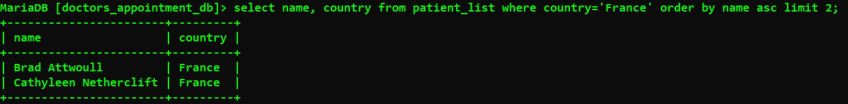

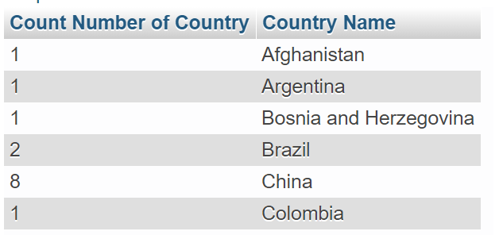**Q7:** display number of patients from each country (order by country) as sample below

Answer:

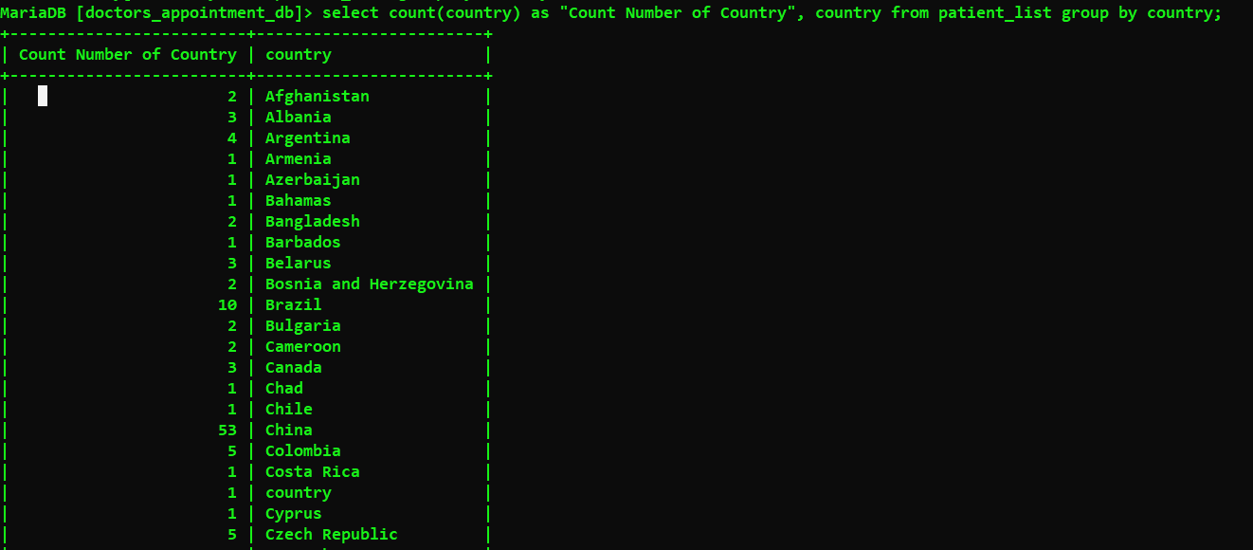

**Q8:** Using the appointment list table, display the total number of appointments

Expected result:

3

Answer:

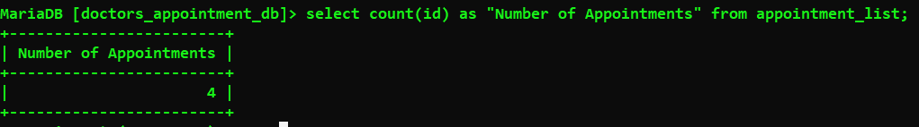

**Q9**: Using the **doctor_schedule** table, display the number of doctors available per day:

Expected result:

**day number of doctors**

Friday 1

Monday 2

Thursday 1

Tuesday 1

Wednesday 2

Answer:

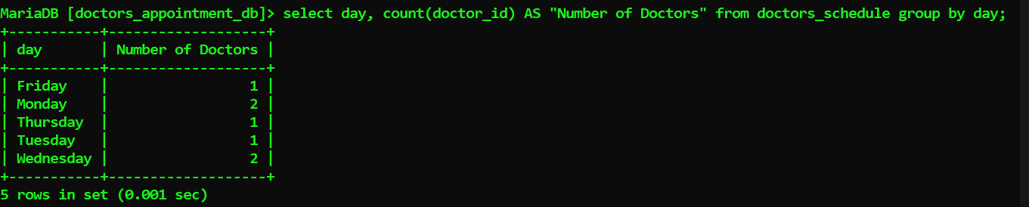

**Q10:** Using the **medical_specialty** table, display the number of medical specialties.

Expected result:

5

Answer:

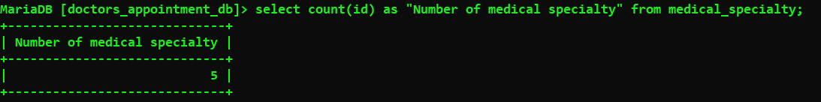

**Q11**: Display the number of appointments scheduled before October 2020.

Answer:

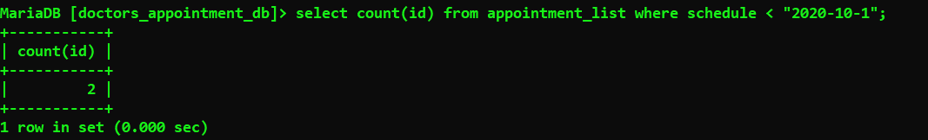

**Q12:** Display all users who have no address and contact.

Expected result:

Administrator

Answer:

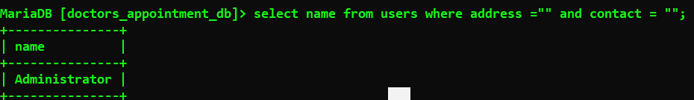

**Q1:** Display the number of patients whose second letter name is ‘e’.

Expected result:

10

Answer:

